**Step to setup login ec2instance from local:**

1. Download Mobaxterm and install.
2. Then click on Session.

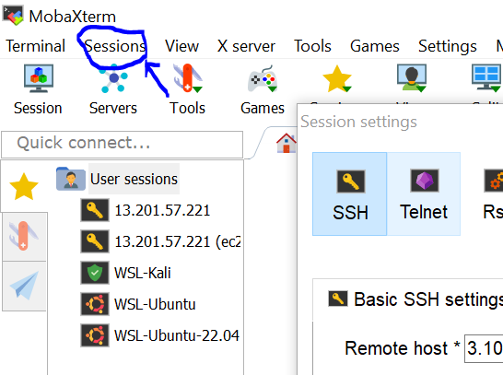

1. Then Click on **SSH**.

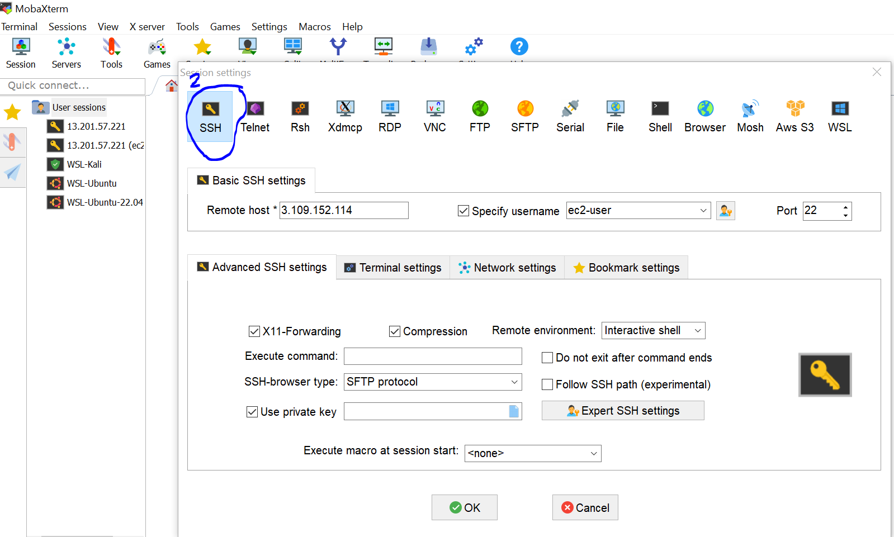

1. In **SSH**, enter public id of ec2 instance and then select on specify username and enter username of ec2instance. By default ec2instance is **ec2-user.**

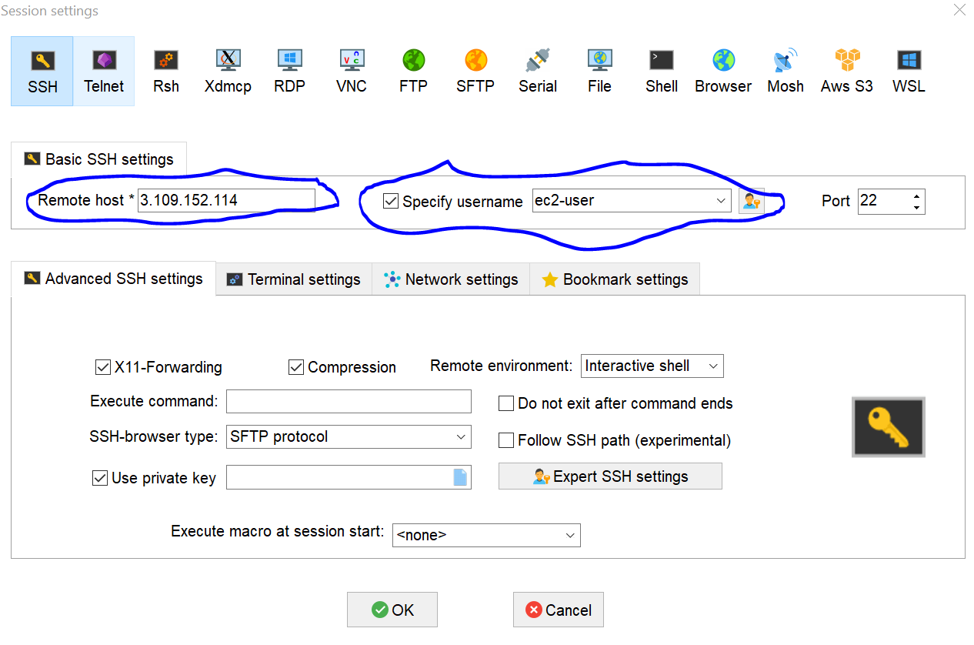

1. Then click on **Advanced SSH settings**.  
     
   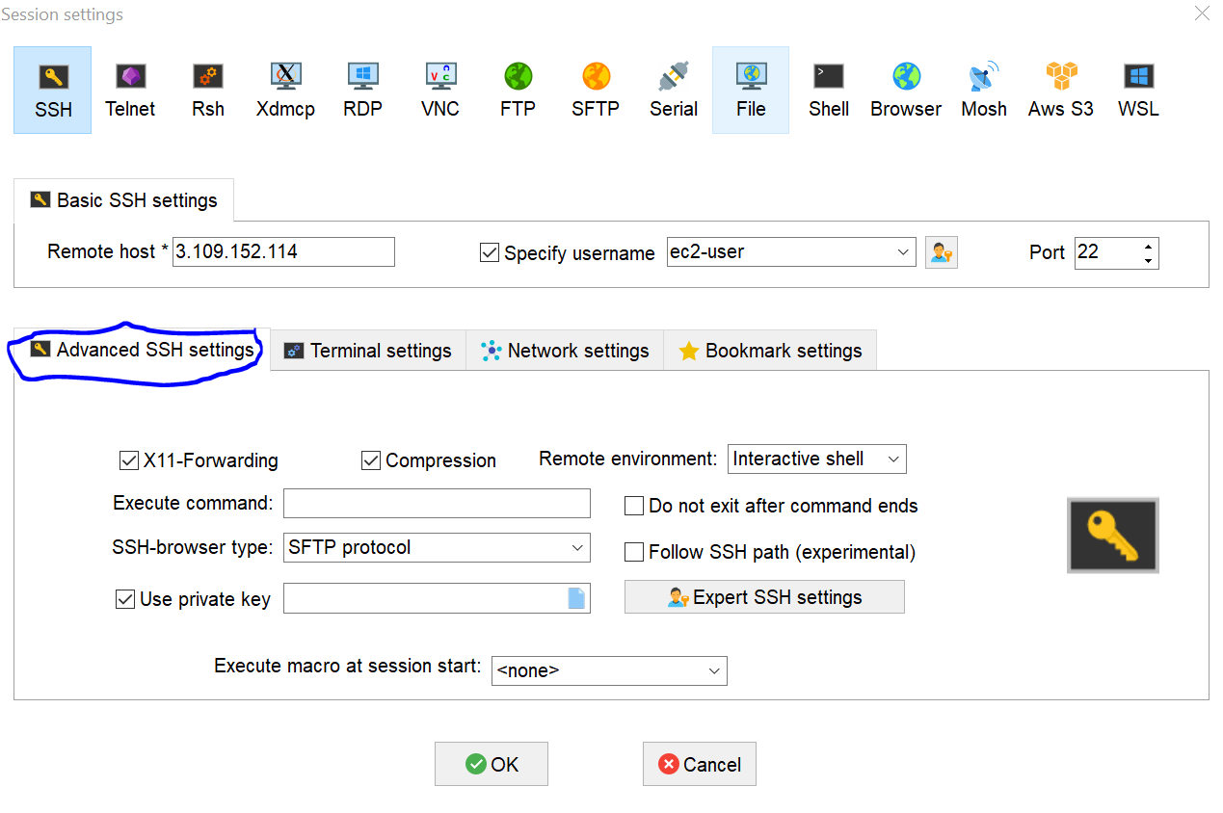

<https://pkg.jenkins.io/debian-stable/jenkins.io-2023.key>

1. In **Advanced SSH settings** select **Use private** key and then upload **.pem file**

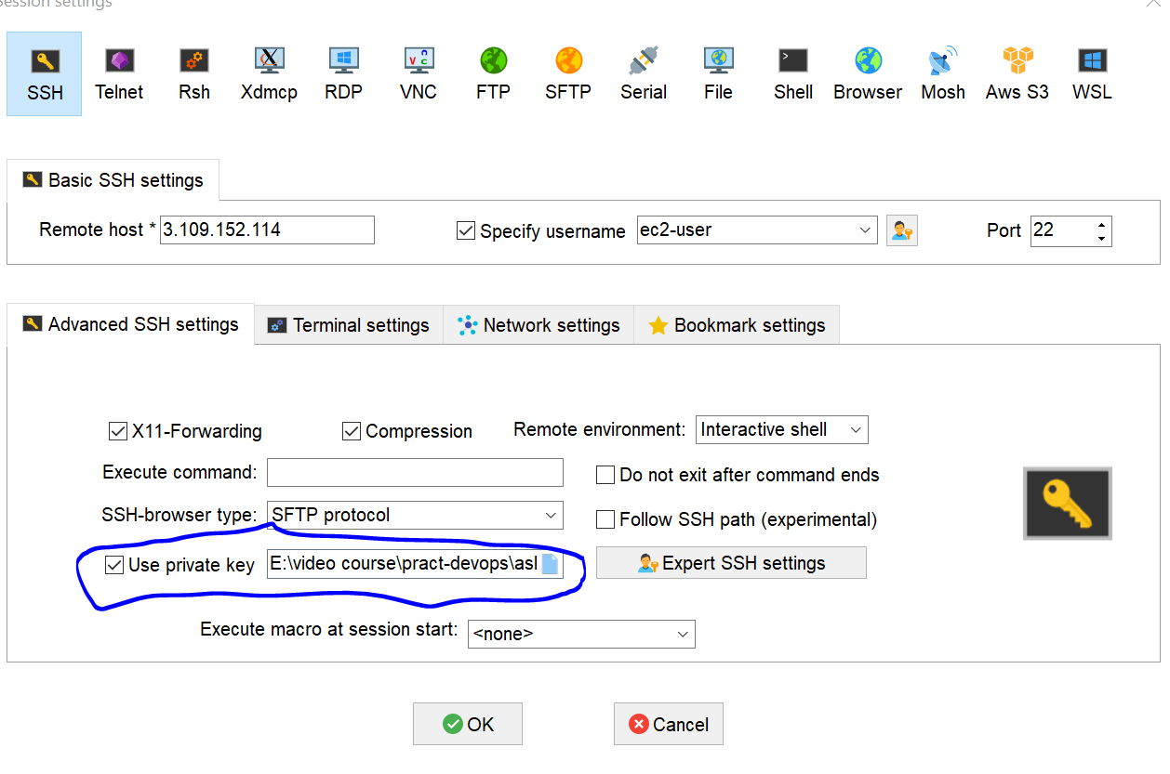

1. Then click on **OK**